IBM Portable PC 5155

随着我们的“Radio Shack”让我们的便携式电脑看起来更像是笔记本电脑，IBM也开发进入这个市场，其于1984年开发了Portable PC 5155。但是，这个便携式电脑犯了一个可怕的错误，那就是其“便携”的重量有13.6公斤，而且有一个9英寸的显示器，价格在$ 4000。而且，你还得随时插在电脑插座上，因为它根本没有电池。

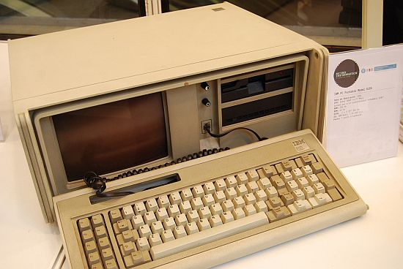

所以，5155 充其量只不过是一个“可以容易搬动的台式电脑”。不过非常感谢IBM的是，他们只用了1年的时间就终止了这个畸形的产物。

目录

• [简介](http://www.techcn.com.cn/index.php?doc-view-140514.html#1)

• [主要参数](http://www.techcn.com.cn/index.php?doc-view-140514.html#3)

• [详解](http://www.techcn.com.cn/index.php?doc-view-140514.html#5)

• [相关链接](http://www.techcn.com.cn/index.php?doc-view-140514.html#7)

* • [参考文献](http://www.techcn.com.cn/index.php?doc-view-140514.html#9)

简介[回目录](http://www.techcn.com.cn/index.php?doc-view-140514.html" \l "section)

　　1984年2月，IBM公司发布IBM 5155个人便携电脑。这款便携电脑采用的CPU是Intel 8088（4.77MHz），配备256K的内存（最大扩充640K），内置显示器为9寸的琥珀黄色显示器，分辨率为640 X200，采用的系统为装在磁盘上的IBM PC-DOS Version 2.10。

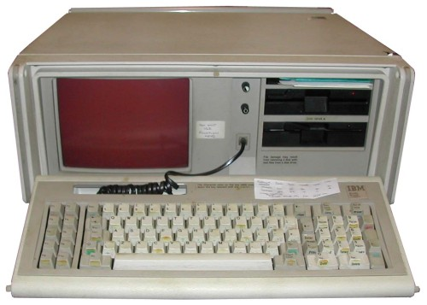

The IBM Portable Personal Computer 5155 model 68 was an early portable computer developed by IBM after the success of Compaq's suitcase-size portable machine (the Compaq Portable). It was released in February, 1984, and was eventually replaced by the IBM Convertible.

The Portable was basically a PC/XT motherboard, transplanted into a Compaq-style luggable case. The system featured 256 kibibytes of memory (expandable to 640 KiB), an added CGA card connected to an internal monochrome (amber) composite monitor, and one or two half-height 5.25" 360K floppy disk drives. Unlike the Compaq Portable, which used a dual-mode monitor and special display card, IBM used a stock CGA board and a composite monitor, which had lower resolution. It could however, display color if connected to an external monitor or television.



The Portable was not a big seller due to the public's confusion over what it really was: It should have been called the Portable XT, which would have been more accurate. "Portable PC" implied the earlier PC technology, which led consumers to believe it was less advanced than it actually was.[citation needed]

The floppy controller card was the same as found in the IBM XT and supported up to four 360K drives (two internal, two external) but was not compatible with the higher-capacity drives then gaining in popularity, notably the 5.25" quad-density ("1.2MB") drives that were standard in the IBM AT and 3.5" 720K drives.

主要参数[回目录](http://www.techcn.com.cn/index.php?doc-view-140514.html" \l "section)

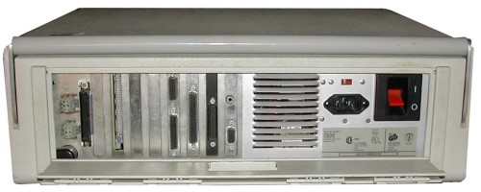

IBM Portable PC 5155

|  |  |
| --- | --- |
| **Model:** | model 68 |
| **Introduced:** | February 1984 |
| **Price:** | US $4225. |
| **Weight:** | 30 pounds |
| **CPU:** | Intel 8088 @ 4.77MHz |
| **RAM:** | 256K, 640K max |
| **Display:** | 9-inch amber display |
|  | CGA graphics, 80 X 25 text |
| **Storage:** | Two 360KB 5.25-inch disk drives |
| **Ports:** | 1 parallel, 1 serial, CGA video |
| **OS:** | IBM PC-DOS Version 2.10 (disk) |

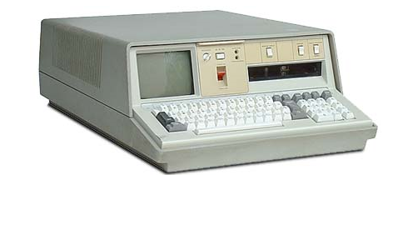

|  |  |
| --- | --- |
|  |  |

|  |  |
| --- | --- |
| **NAME** | PC Portable - Model 5155 |
| **MANUFACTURER** | IBM |
| **TYPE** | Transportable |
| **ORIGIN** | U.S.A. |
| **YEAR** | 1984 |
| **BUILT IN LANGUAGE** | Basic |
| **KEYBOARD** | QWERTY / AZERTY mechanical keyboard 10 function keys and numeric keypad, 83 keys |
| **CPU** | Intel 8088 |
| **SPEED** | 4.77 Mhz |
| **CO-PROCESSOR** | 8087 arithmetic co-processor |
| **RAM** | 256 kb (up to 640 kb) |
| **ROM** | 40 kb |
| **TEXT MODES** | 25 x 80 |
| **GRAPHIC MODES** | CGA modes : 320 x 200 / 640 x 200 |
| **COLORS** | 9'' built-in amber display |
| **SOUND** | Beeper |
| **SIZE / WEIGHT** | 50 x 43 x 20 cm / 13,6 kg |
| **I/O PORTS** | 7 expansion slots |
| **BUILT IN MEDIA** | 1 or 2 x 5''1/4 disk-drives (360k) |
| **OS** | PC-DOS 2.1 |
| **POWER SUPPLY** | 100-240 v, 50-60 Hz |
| **PRICE** | 3811 http://www.techcn.com.cn/uploads/201001/1262531806LJeX8zDC.gif(France, 84) |

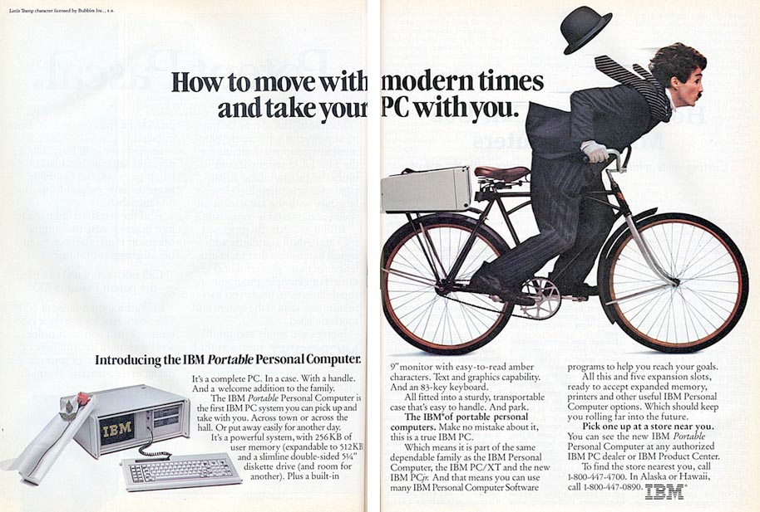

详解[回目录](http://www.techcn.com.cn/index.php?doc-view-140514.html" \l "section)

|  |
| --- |
| http://www.techcn.com.cn/uploads/201001/12625318069CKU1ep2.jpg |

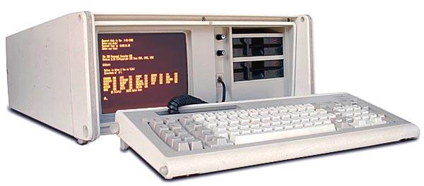  
  
Excerpt from the original IBM announcement:

|  |
| --- |
| The IBM Portable Personal Computer 5155 Model 68 consists of a lightweight case with a carrying handle containing a built-in. 9-inch, amber composite display, one 5 1/4-inch double sided diskette drive (with space for an optional second drive), and two IBM Personal Computer attachment options (diskette adapter and colour/graphics adapter).   The unit also has a new, lightweight keyboard and a universal power supply. The system board is the same as that of the IBM Personal Computer XT with 256Kb of memory that is expandable to 512Kb using the memory expansion option.   Five expansion slots are available for the connection of most IBM Personal Computer options. The system has identical function and performance characteristics to an equivalently configured IBM Personal Computer. |

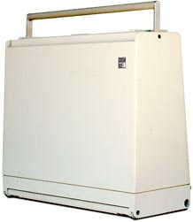The Portable is not really a new, redesigned IBM computer, it's actually just the same motherboard as the IBM desktop system installed in a carry-around case with a built-in monitor and floppy drives.   
  
Because of this, the eight internal expansion slots aren't quite as useful as they could be. The floppy drives take-up a lot of room, so most of the slots cannot accept full-length cards:

|  |  |  |
| --- | --- | --- |
| Slot | Max length | Card installed |
| 1 | 13 inch | Video Controller |
| 2 | 13 inch | empty |
| 3 | 10 inch | Disk controller |
| 4 | 5 inch | Parallel port |
| 5 | 5 inch | Async (serial) |
| 6 | 5 inch | empty |
| 7 | 4 inch | empty |
| 8 | 4 inch | empty |

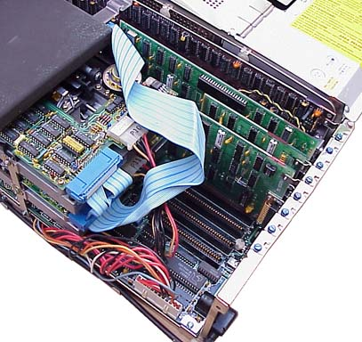  
It's considered portable, but only because of the built-in monitor and drives. There are no batteries, you still have to plug it into the 110VAC outlet.   
  
The 5155 was IBM's response to the Compaq Portable computer, which was released one year prior, costs $700 less, but has the same CPU and runs just as fast. The Compaq was advertised as being 100% IBM compatible, and even weighs slightly less.

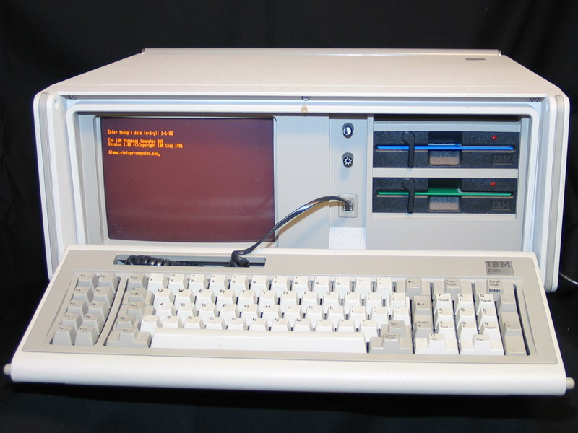

This wasn't IBM's first portable computer, that would be the IBM 5100, released in 1975 - It was revolutionary, and extremely expensive.



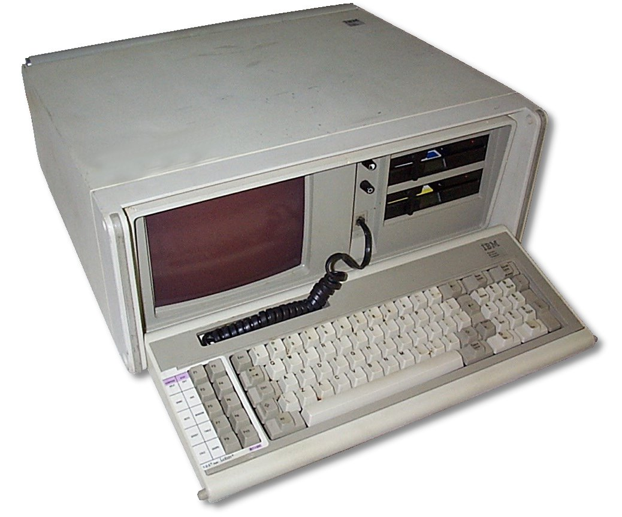

相关链接[回目录](http://www.techcn.com.cn/index.php?doc-view-140514.html" \l "section)

• [IBM 5155](http://www.can.ibm.com/helpware/5155.html) from [IBM of Canada](http://www.can.ibm.com/)

• [QUE: Upgrading & Repairing PCs Eighth Edition](http://cma.zdnet.com/book/upgraderepair/)

[Obsolete Technology Website: IBM Portable PC 5155 model 68](http://oldcomputers.net/ibm5155.html)

参考文献[回目录](http://www.techcn.com.cn/index.php?doc-view-140514.html" \l "section)

http://oldcomputers.net/ibm5155.html

http://en.wikipedia.org/wiki/IBM_Portable_Personal_Computer  
http://www.old-computers.com/museum/computer.asp?st=1&c=446